Q. What are the 3 types of relationships different tables can have in SQL

A. One-to-one, One-to-many, Many-to-many

Q. Whats the table called that links two tables in a many-to-many relationship?

A. An Association table, or a junction table

What type of relationship is this?

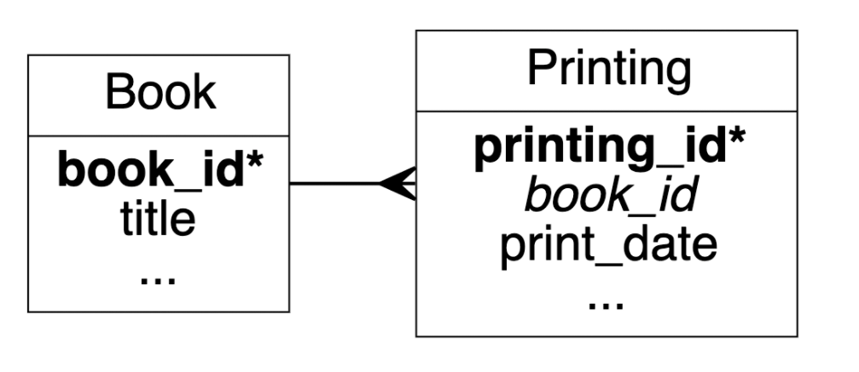

One to many

Whats the purpose of a foreign key?

A foreign key relates to tables together based on a common field

What type of relationship is this?

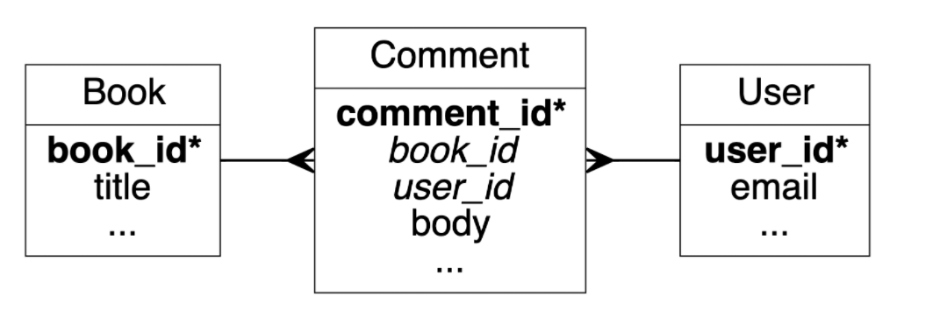

Many to many

Why do we try to avoid keeping null values in our database?

Null values can be considered bad data, they slow our database down

What is normalization?

Planning out your database to reduce repetition and

Why don’t we want to store everything in one table?

It slows our database down